Outline:
- Make a folder for the bid request in the Sales drive.
- Add the bid request to the Sales Project Log.
- Identify any questions concerning what the dealer wants.
- Respond to the dealer thanking them for the request and asking said questions.
- Reach out to suppliers for quotes on non-stock products.
- Check the climate zone.
- Check the snow load.
- Reach out to design on code questions or sales drawings.
- Bid the building based off spec and drawings.
- Send bid to customer.

Creating a Quote Folder
- Open the file explorer, click on the sales drive.
- Open the sales folder for the current year.

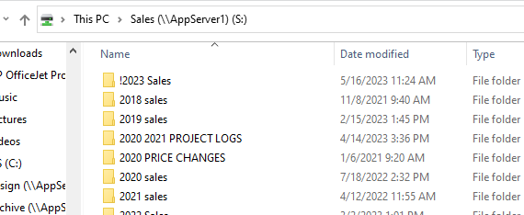

- Open the bid sub-folder.
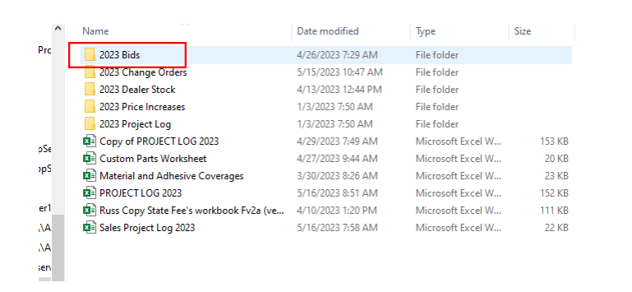

- Open the folder for the current month.

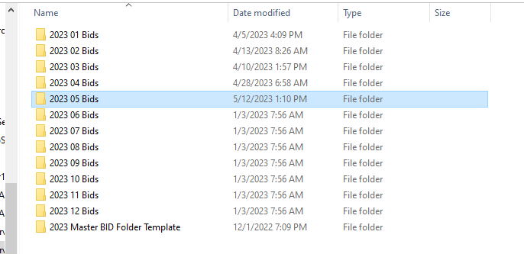
- Create a copy of the Master Bid folder Template.
- Rename the copied folder using the following naming convention:
NWBS BOM BID YYMMDD, BLDG Width X BLDG Length, Building Description, Company, Customer Name.

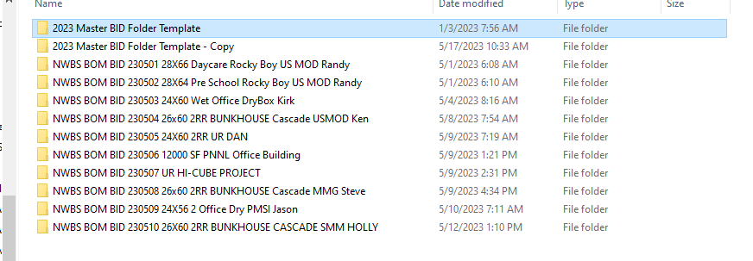

- Save Quote documents in the appropriate sub folders within the quote folder.

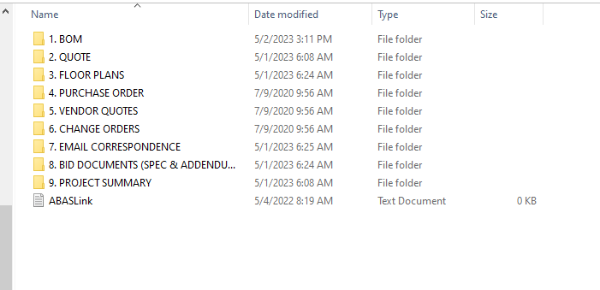

- BOM folder contains notes and calculations for the quote BOM, and the quote PDF generated by ABAS.

Creating a Quote in Praxis

- Review the dealer quote request to ask questions necessary to correctly price the building.
  - End location, roof type, roof pitch, state tags desired, etc.
- Send quote requests for non stock items. You can find a link to suppliers below.
  - P:\Vendor List.xlsx
- Log in to Praxis and click on Maintain Quotes.
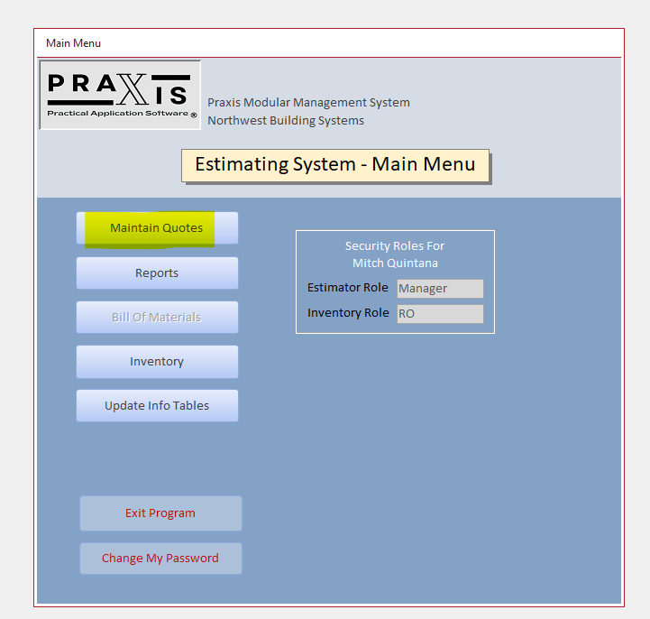
- Then click Estimate Building
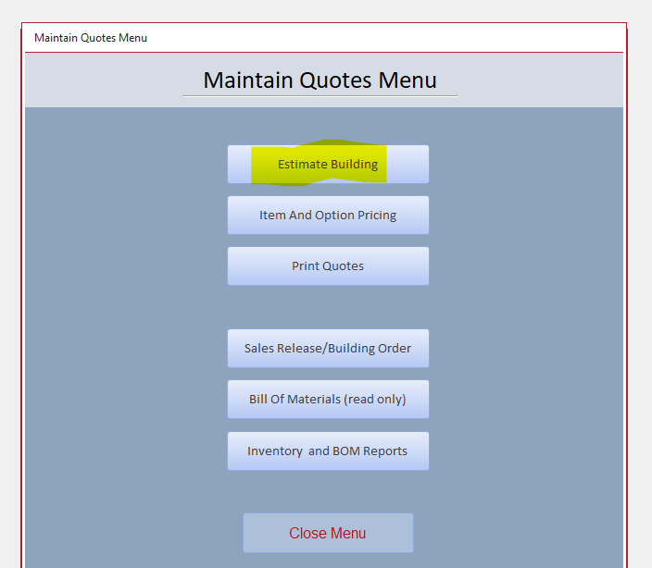
- Then try to find a similar building to the one you are estimating by searching for a combination of building type, size, and customer.
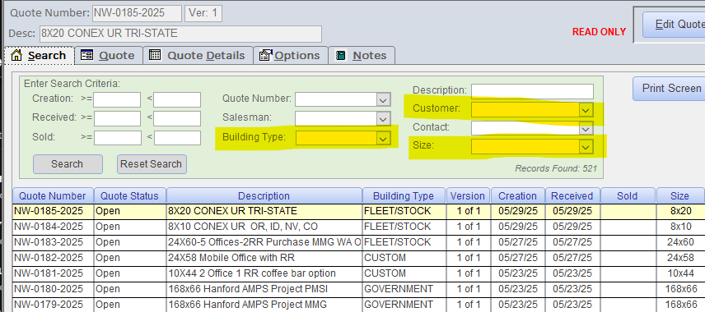
- Once you find a quote that is similar to the one you are working on, duplicate the quote. If you want to start a bid from scratch. You can do that as well by clicking New Quote on the search page.
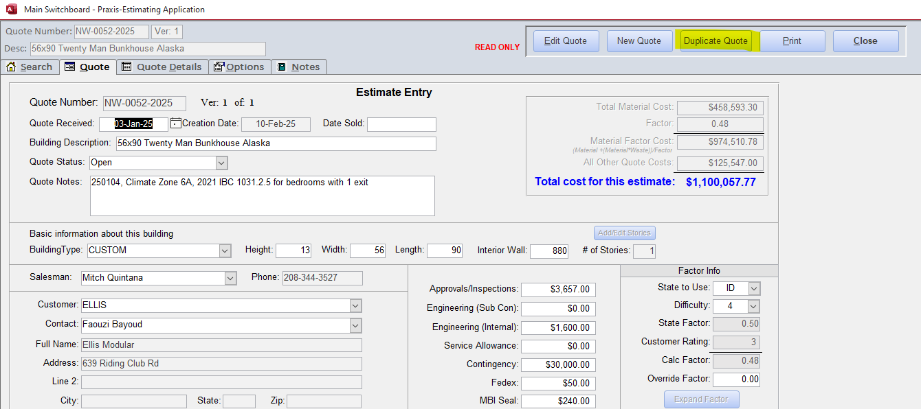

- Whether you duplicated a quote or started from scratch, update the quote page for the following items:
  - Building Description
  - Quote Notes
    - Put the bid folder number in here.
  - Building type
  - Height
    - 11 feet on modules up to 44 feet, 12 feet on modules 45-70 feet, 13 feet on modules 70+
  - Width
    - Make sure you are using full module widths in increments of 2 feet. For instance, a building that is 26x64 would be entered as 28x64 due to sheet goods coming in intervals of 2’.
  - Length
  - Interior Wall
    - Do a BlueBeam takeoff to determine interior wall length. Don’t count double walls only lengths with full finish. Our estimating software pulls length of finish from this number. Often your linear feet of wall framing ends up being more than the interior wall length input here.
  - # of Stories
  - Customer
  - Customer Contact
  - State to Use
  - Difficulty
  - MBI Seal
    - Value is number of mods x $30.
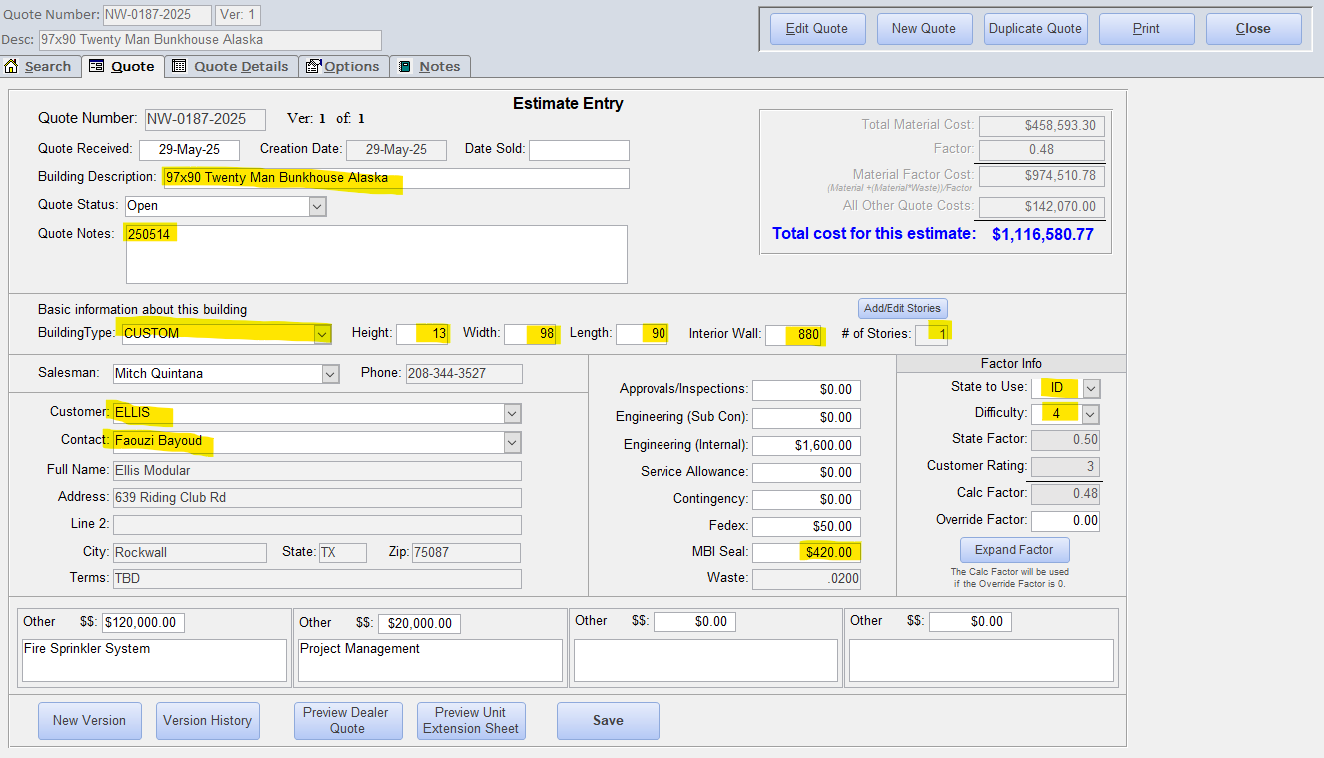
- Go to quote details to begin working on the quote.
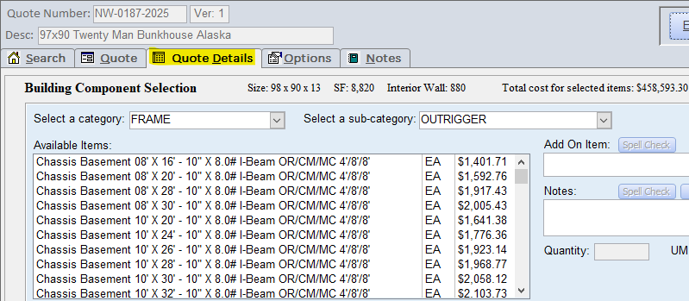
- Add your chassis to the quote. Make sure to add extra outriggers for the exterior walls. Outriggers are 4’ on center on the exterior walls so divide your building length by 8 and round up to determine how many extra pairs of outriggers you’ll need.
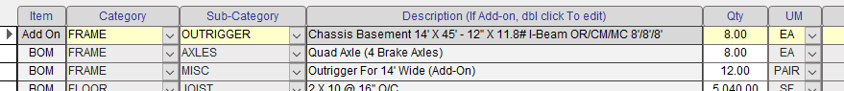
- Add your flooring. Remember that sheet vinyl requires ¼” underlayment. Our standard sheet vinyl is 13’2” so calculate square footage based on linear footage needed multiplied by 13’2”.
- Find the climate zone for the building by checking the Building America Center. If multiple state tags are asked for, design according to the highest climate zone in the states asked for. If a state has a climate zone 7 or 8, ask the dealer if they want the quote to include those climate zones as insulation values increase dramatically.

- Now that you know the climate zone, check the quote insulation values in the Insulation Values by State Spreadsheet (Image Below for Reference). We will almost always use an unvented roof system with continuous insulation. Unvented roofs will use joists vs vented will use trusses. Use a vented roof and trusses for double wides with a 2/12 pitch or greater. May consider for R60 roofs as well.
- Add the exterior wall insulation, sheathing, siding, and finishes.
  - Use the wall insulation values from the last step.
  - Use 7/16” OSB sheathing on side and end walls if doing lap siding or cement board panels. If mod length is 4x greater than the width, add 7/16” OSB to end walls only for shear.
  - Add siding of dealer’s choice.
  - Add VCG or customer interior finish of choice.
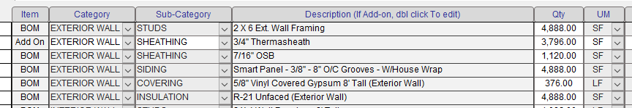
- For interior walls:
  - Add how many linear feet of studs you’ll need including 2x6 studs. This number is typically higher than the linear feet of interior walls on the main quote page.
    - Add your linear feet of 2x6 upgrade.
    - Add linear feet of walls extended to rafters (note where you are extending).
  - Add your interior coverings to the quote including FRP. Note where your finishes are going and to what extent.
    - i.e. does your FRP only have 10’ sections in a bathroom or is it a full FRP wainscot?
  - Decide on how many columns you have that are exposed vs concealed. Typically each mod has 4 posts and max span is around 34’ unless the snow load is greater than 40#.
  - Add R11 insulation to interior walls at restroom and wherever else desired. Be sure to note where insulation is included in the quote.
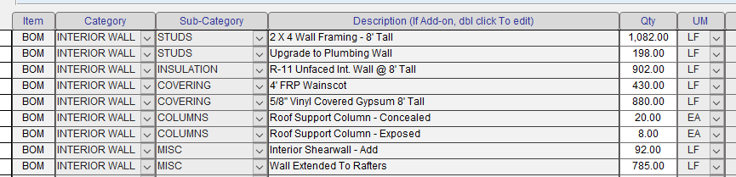
- Add cove base to the quote. Factory standard is 4” vinyl. The quantity is determined by the linear feet of interior walls on the quote page.
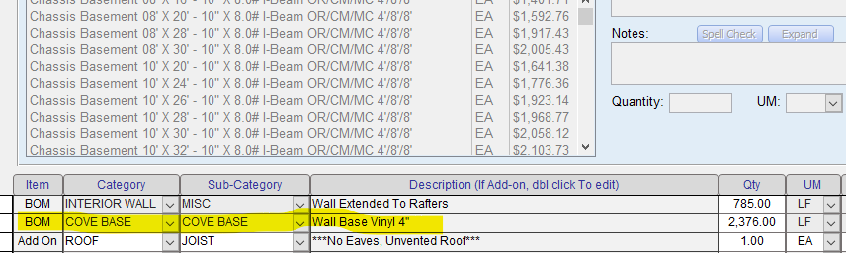
- To determine the roof load, check the ASCE Hazard Tool. Set the version to ASCE/SEI 7-16, risk category to II, site soil to Default and ask for snow load.
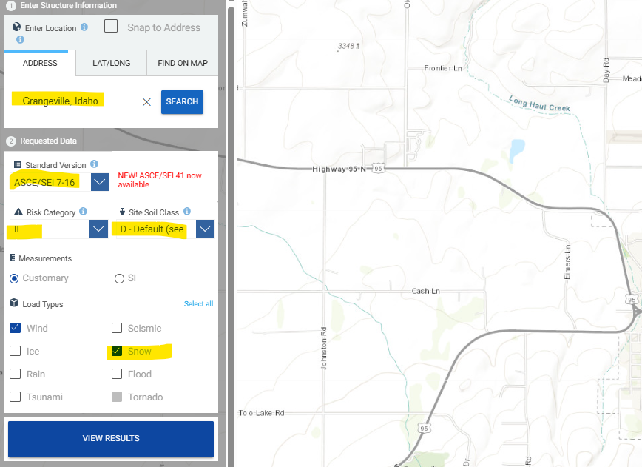
- Add joists or trusses to quote based on snow load and roof venting. For snow loads over 40#, email engineering.dept@sunbeltmodular.com to ask for joist spacing. If using trusses, reach out to truss manufacturer for quote/spacing.
- For mate beams, if span is greater than 28’ in any area, reach out to engineering.dept@sunbeltmodular.com with the snow load, building section, floor plan, and location. Ask if we need to double the LVL mate beam or if we need to move to metal clear spans.
- If
- she

